Experiment No. 10
MINI PROJECT - I : GRAPH DATABASE DESIGN & MODELING
1. Problem Statement
Background & Industry Context: In the global pharmaceutical industry, ensuring patient safety requires complete, immutable end-to-end traceability of prescription drug batches from active pharmaceutical ingredient (API) suppliers to factories, distribution depots, pharmacies, and healthcare clinics. According to the World Health Organization (WHO), counterfeit and substandard medications account for over $200 billion in illicit commerce annually, posing catastrophic public health hazards.
The Relational Database Bottleneck: Traditional Relational Database Management Systems (RDBMS) model supply chains using highly normalized tabular schemas across separate tables (Suppliers, PurchaseOrders, ProductionBatches, Shipments, Warehouses, Dispensations). Answering vital traceability questions—such as 'Trace this exact blister pack back 6 tiers to identify the chemical lot and inspection status' or 'Identify all hospitals that received drugs from a contaminated manufacturer'—requires deeply nested, multi-table SQL JOIN operations and recursive Common Table Expressions (CTEs). As data volume expands, recursive relational queries suffer from exponential performance degradation (O(n^k)), high index-lookup latency, and brittle table joins.
The Graph Database Solution: To overcome these limitations, this project designs 'PharmaTrack'—a high-performance Graph Database system built on Neo4j. By utilizing native index-free adjacency, entities (Suppliers, Manufacturers, Batches, Warehouses, Pharmacies, Inspectors) are stored as nodes, while transactions (SUPPLIED, PRODUCED, SHIPPED, STORED, DELIVERED_TO, DISPENSES, AUDITED) are stored as direct physical relationship pointers. This allows provenance tracing, counterfeit isolation, and cold-chain temperature verification to execute in constant O(1) traversal time per relationship hop, regardless of total database size.
2. Objectives
• Design a Graph Data Model: Formulate a property graph schema that accurately represents physical supply chain tiers, intermediate custody handoffs, and regulatory oversight.
• Establish Node & Edge Schemas: Identify distinct node labels and rich property sets representing critical product attributes (batch numbers, expiry dates, dosage, dosage form) and logistics metrics (transit temperature, carrier, timestamps).
• Enable Rapid Provenance & Track-and-Trace: Formulate traversable graph structures capable of tracing complete lineage from raw chemical supplier to dispensing pharmacy in a single query.
• Implement Counterfeit & Anomaly Detection: Structure the graph model to detect broken custody chains, unauthorized suppliers, and counterfeit drugs dispensed without valid manufacturer pedigree.
• Cold-Chain Logistics Compliance: Store and evaluate environmental telemetry (temperature logging) along shipping edges to flag compromised temperature-sensitive medications like Insulin.
3. Graph Schema / Model
Architecture Overview: The PharmaTrack property graph model consists of 6 primary Node labels and 7 directed Relationship types. Nodes encapsulate domain entities along with descriptive properties, while relationships represent physical flow of goods, processing transformations, and regulatory audits.
3.1 Entities (Nodes) and Attributes (Properties)
Node Label | Description | Key Properties & Data Types
Supplier | Provides raw chemical ingredients / APIs | id (String, Unique), name (String), country (String), certified (Boolean)
Manufacturer | Licensed pharmaceutical factory producing batches | id (String, Unique), name (String), city (String), gmpCompliant (Boolean)
Batch | Physical production lot of manufactured medication | batchId (String, Unique), drugName (String), mfgDate (Date), expiryDate (Date), status (String)
Warehouse | Regional logistics center & cold-storage depot | id (String, Unique), name (String), city (String), coldChainSupported (Boolean)
Pharmacy | Licensed dispensary or hospital pharmacy | id (String, Unique), name (String), licenseNo (String), city (String)
Inspector | Regulatory authority conducting compliance audits | id (String, Unique), name (String), agency (String)

3.2 Relationships between Entities
Relationship Type | Source -> Target | Description | Edge Properties
SUPPLIED | Supplier -> Manufacturer | Raw ingredient or API shipment | ingredient (String), date (Date), lotNo (String)
PRODUCED | Manufacturer -> Batch | Manufacturing output linking factory to batch | date (Date), totalUnits (Integer)
SHIPPED | Manufacturer -> Warehouse | Wholesale logistics transit with cold telemetry | dispatchDate (Date), carrier (String), tempCelsius (Float)
STORED | Warehouse -> Batch | Inventory holding in climate-controlled zone | shelfZone (String), entryDate (Date)
DELIVERED_TO | Warehouse -> Pharmacy | Distribution shipment to retail/hospital pharmacy | deliveryDate (Date), qtyReceived (Integer)
DISPENSES | Pharmacy -> Batch | Retail dispensing connection to patient stock | batchId (String)
AUDITED | Inspector -> Batch | Regulatory quality assurance inspection | auditDate (Date), outcome (String), certNo (String)

3.3 Graph Schema Design Diagram
Schema Visualization: Figure 1 below illustrates the formal Graph Schema/Model for the PharmaTrack system. Directed edges represent the sequence of manufacturing, custody transfer, and auditing operations, demonstrating how any end-consumer batch can be traversed backwards to source suppliers in O(1) graph hops.
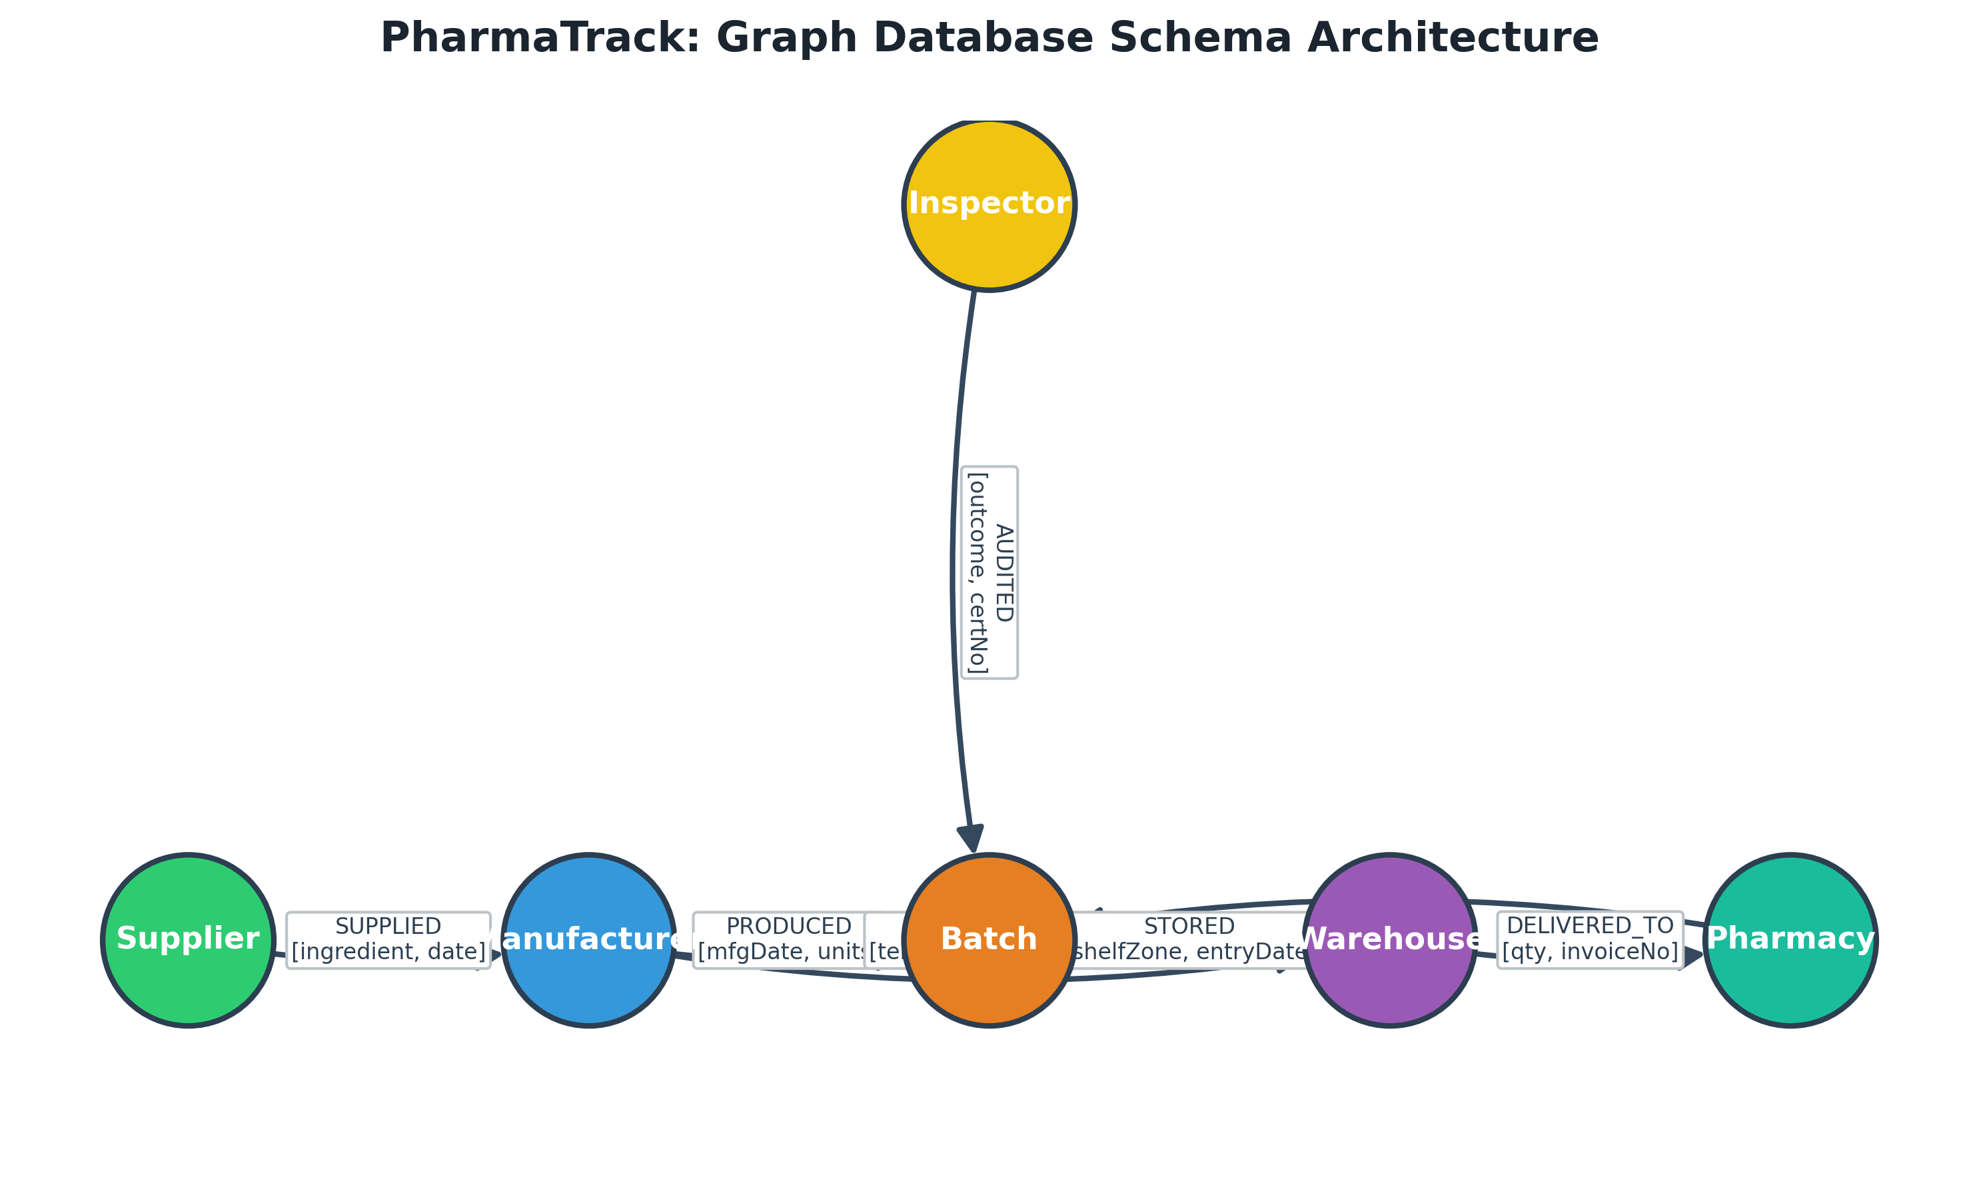
Figure 1: PharmaTrack Graph Schema Architecture (Entities, Relationships, and Properties)

